Sustainable Fashion: How Custom Clothing Can Benefit Your Family Budget

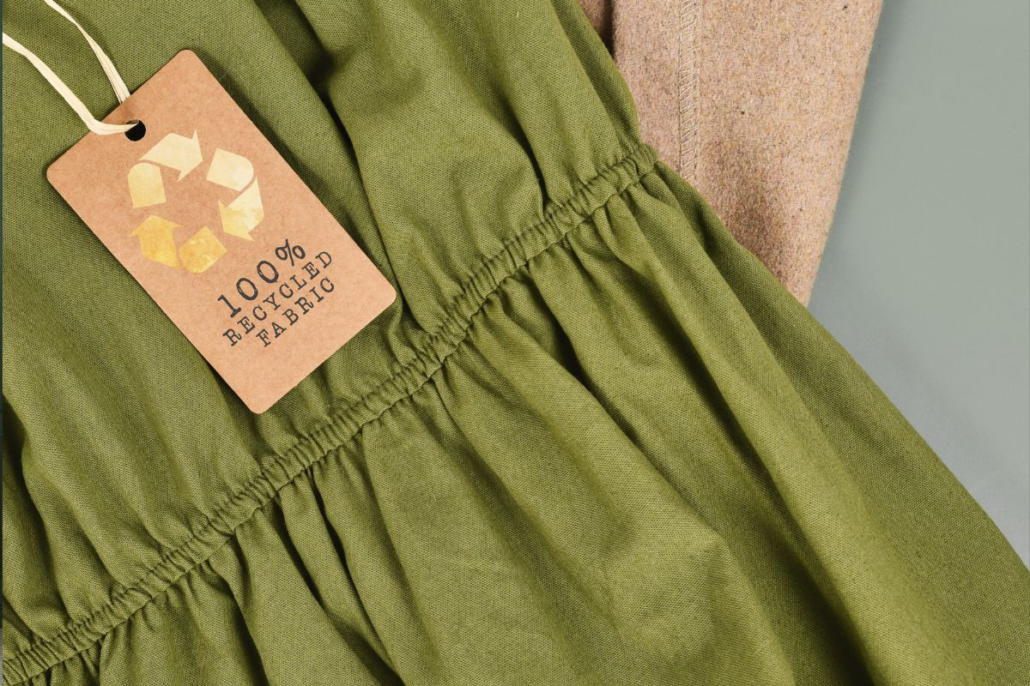

The fashion industry is a behemoth with a significant environmental footprint. The relentless pursuit of trends and the disposable nature of fast fashion have led to a crisis of overconsumption and waste. However, there's a growing movement towards sustainable fashion, and it's closer to home than you might think. Custom clothing offers a practical and stylish way to reduce your family's environmental impact while also saving money.

# The High Cost of Fast Fashion

Fast fashion, characterized by its low cost and rapid turnover, has become synonymous with the fashion industry. While it offers affordable options, the environmental and social costs are staggering. From the excessive use of water and chemicals in production to the exploitation of workers, fast fashion leaves a detrimental mark on our planet and its people.

Moreover, the disposable nature of fast fashion encourages impulsive buying and contributes to overflowing wardrobes. Clothes often end up unworn or discarded after a few wears, adding to the landfill crisis.

# The Sustainable Solution: Custom Clothing

Custom clothing, on the other hand, offers a refreshing alternative to the fast fashion cycle. By opting for custom pieces, you're making a conscious choice to reduce your consumption and support a more sustainable approach to fashion.

## 1. Quality Over Quantity

* Durability: Custom clothing is often made from higher quality materials designed to last. This means fewer replacements and less waste in the long run.
* Timeless Style: Custom pieces can be designed with classic elements, ensuring they remain stylish and wearable for years to come.

## 2. Reducing Waste

* Personalized Fit: Custom clothing can be tailored to fit perfectly, reducing the likelihood of returns and unwanted items.
* Mindful Consumption: By investing in pieces you truly love and will wear frequently, you're actively reducing your consumption of new clothes.

## 3. Cost-Effective in the Long Run

* Value for Money: While the initial cost of custom clothing might be higher, the long-term savings can be substantial.
* Reduced Impulse Buying: Custom pieces are often more thoughtfully chosen, reducing the temptation of impulsive purchases.

# Custom Clothing: A Versatile Choice

Custom clothing is a fantastic starting point for your sustainable fashion journey. They offer a blend of style, durability, and personalization.

* Family Uniforms: Create matching [**custom embroidered t shirts**](https://www.cliftonclothing.com/all/custom-cotton-tshirts) for family outings, vacations, or special occasions.
* Team Spirit: Design custom t-shirts for sports teams, clubs, or school groups.
* Personalized Gifts: Create unique and thoughtful gifts for birthdays, anniversaries, or holidays.
* Wardrobe Staples: Invest in high-quality, custom-embroidered t-shirts that can be dressed up or down.

# Finding Sustainable Materials

When choosing custom clothing, it's essential to consider the environmental impact of the materials used. Opt for sustainable fabrics like organic cotton, recycled polyester, or Tencel. These materials have a lower environmental footprint compared to conventional options.

# Supporting Local Businesses

Another way to enhance the sustainability of your custom clothing choices is by supporting local businesses. Many small-scale custom clothing companies prioritize ethical practices and use locally sourced materials.

# Caring for Your Custom Clothing

To maximize the lifespan of your custom pieces, proper care is essential.

* Follow Care Instructions: Adhere to the care labels to prevent damage and maintain the fabric's quality.
* Gentle Washing: Wash delicate items in cold water and avoid harsh detergents.
* Proper Drying: Air-drying is generally the best option for extending the life of your clothes.
* Ironing with Care: Use the appropriate iron setting and protect delicate fabrics with a pressing cloth.

Embracing sustainable fashion is a journey, not a destination. By choosing custom clothing, you can make a significant impact on your family's budget and the environment. Remember, it's about quality over quantity, thoughtful consumption, and supporting ethical practices. Let's redefine fashion as a force for good.